

**KHULNA UNIVERSITY OF ENGINEERING &TECHNOLOGY**

Department of Computer Science and Engineering (CSE)

**PROJECT ON CSE 3100**

**Course Title:** Web Programming Laboratory

Project Title: Coffee Shop Website

Platform: ASP

***Submitted To:***

**1.Prottoy Saha**

Assistant Professor

Department of Computer Science and Engineering (CSE)

Khulna University of Engineering & Technology (KUET)

**2.Sunanda Das**

Assistant Professor

Department of Computer Science and Engineering (CSE)

Khulna University of Engineering & Technology (KUET)

***Submitted by:***

Subah Nawar

**Roll:** 1807006

**Year**: 3rd **Semester:** 1st

**Submission Date**: July 21,2022

**Objectives:**

1. To develop a coffee shop website using HTML, CSS, JavaScript, ASP.Net and MySQL relational database management system
2. To create a website that uses cookies and session for state management
3. To build a website that will have both admin and user panel with their respective functionality
4. To create a website that will let users to register to the website by creating a new account, then sign in to the website
5. To create a website where user panel will be able to order menu items, book a table and give feedback and admin panel will update menu, gallery, event slider and see user feedbacks

**Introduction:**

Coffeeta is a coffee shop website developed using html, css, javascript as frontend language and asp.net as backend language. It is a simple, user-friendly website. HTML provides the basic structure of sites, which is enhanced and modified by other technologies like CSS and JavaScript. CSS is used to control presentation, formatting, and layout. JavaScript is used to control the behavior of different elements.

ASP.NET is a web development platform, which provides a programming model, a comprehensive software infrastructure and various services required to build up robust web applications for PC, as well as mobile devices.

ASP.NET works on top of the HTTP protocol, and uses the HTTP commands and policies to set a browser-to-server bilateral communication and cooperation.

ASP.NET is a part of Microsoft .Net platform. ASP.NET applications are compiled codes, written using the extensible and reusable components or objects present in .Net framework. These codes can use the entire hierarchy of classes in .Net framework.

**Detailed Description:**

The website has two panels:-

1. **Admin Panel:**

The admin panel exists to control and monitor the flow of the website. Firstly the admin has to login in order to see the current condition of the website. Once logged in it takes the admin to the homepage. From there admin can go to admin layout pages that are only accessible by admin and also can see the website as a normal user. Admin will handle all the menu items, gallery images, slider for home page, booking of table, editing status of orders by user etc. Admin can update existing menu item’s price and other details. They can also see how the website looks to the user and also will have another navigation bar to handle its administrative tasks such as insert, update and delete.

1. **User Panel:**  User will be able to see different pages of the website. They can see the available menus, gallery if the shop and learn more about the shop through gallery and various video and social media links. They can also register their account and then place order for food items. They can also reserve a table prior through book a table page. Finally they can leave a feedback or may contact us through contact us page. In order to place an order or booking, user needs to login first. If they haven’t registered yet, they have to register first. After registering they will be redirected to homepage of the website. Every user will have a cart and table menu where they can see their ordered item and booked table details respectively.

**FlowChart Diagram:**

Flow chart showing the working flow of the website:-

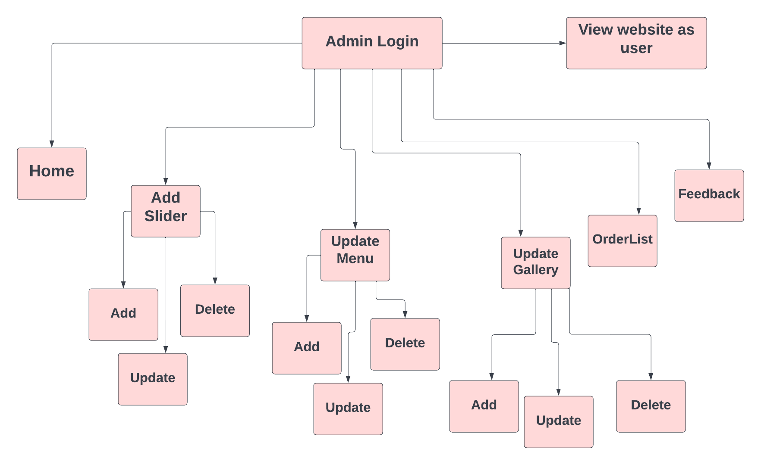

Booking List

**Fig 1:Admin Panel**

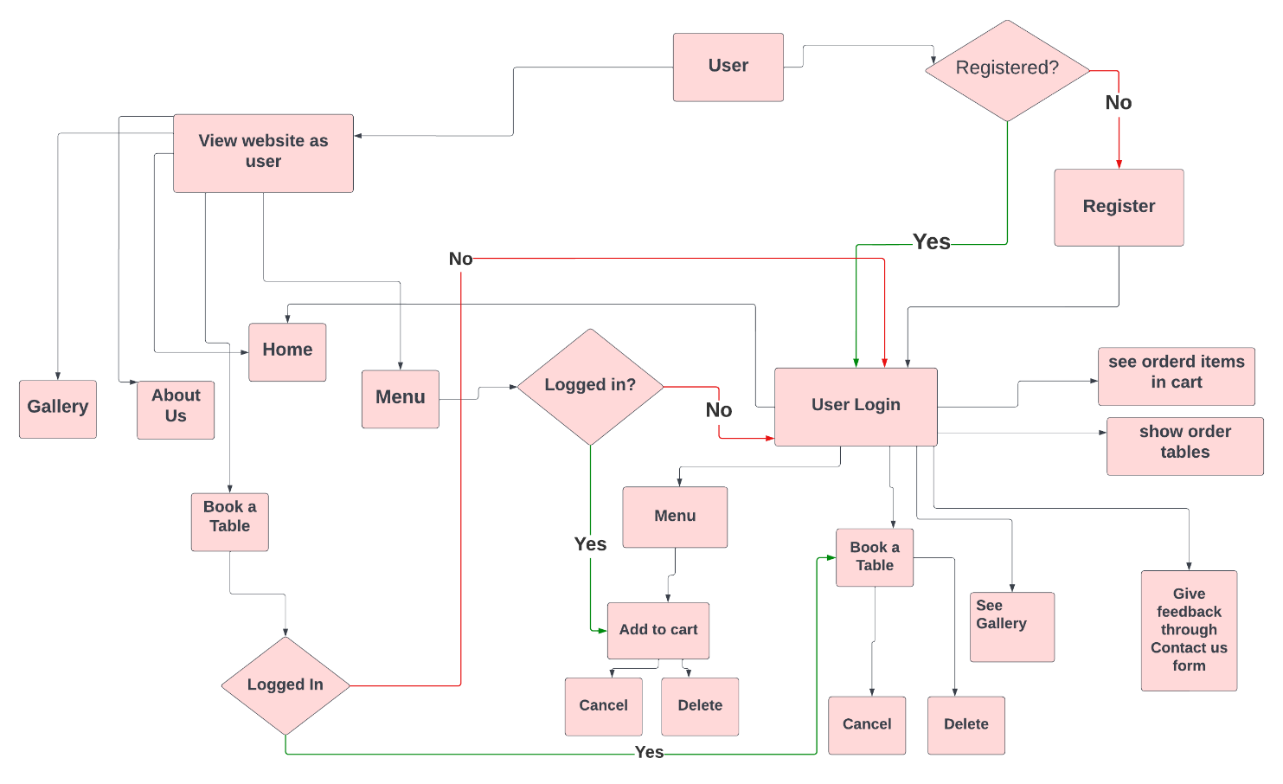

**Fig 2: User Panel**

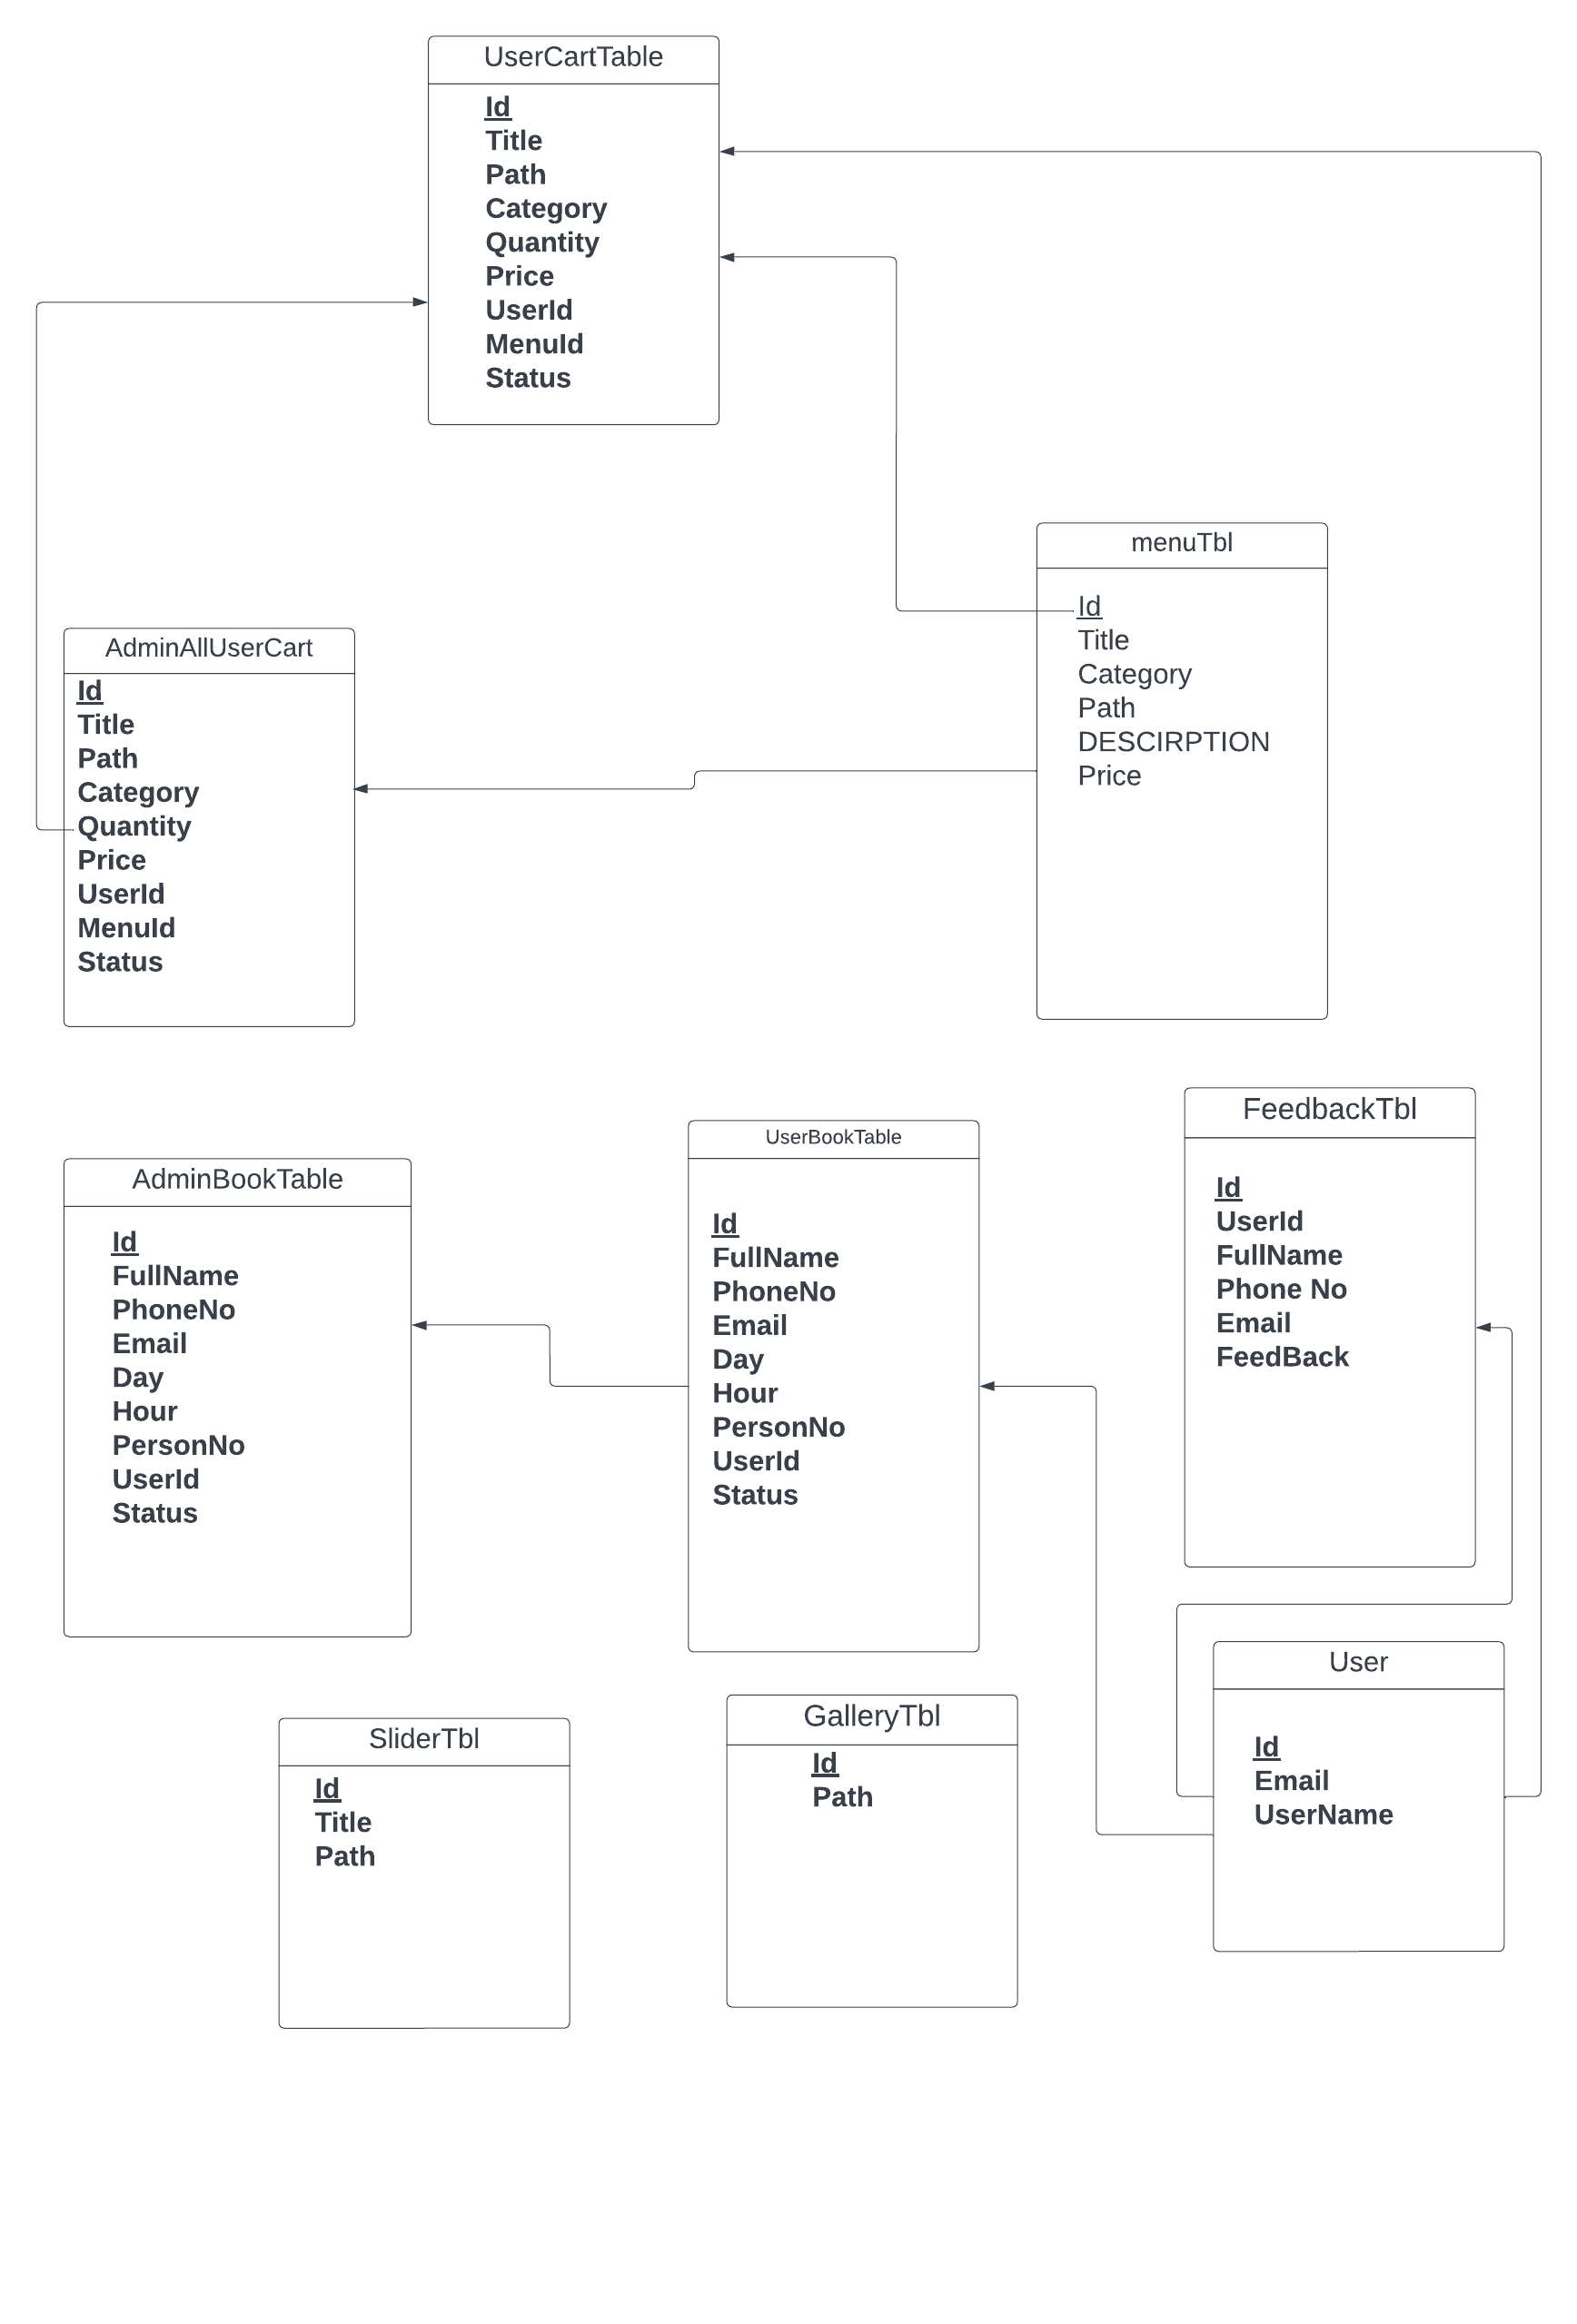

**Figure 3: Schema Diagram**

**Discussion and Conclusion**:

The website was built as a demonstration of AS.Net project of web development lab. The main focus was to be able to create a user-friendly website that is interactive and also secure. Although the website is far from the initial plan for the website. That happened due to the inexperience with web development. It would have been possible to develop and secure the website more both on client side and server side, with more time and experience. The contents of the web development lab was carefully implemented throughout the project. There are scopes to develop the project on greater level which is expected to be developed with experience and knowledge learned through the project. Besides continuous and tireless effort, the guidance of my respected teachers has also shaped this project as a successful outcome. I would like to express my humble gratitude for their valuable advices. Hence, it can be said that the project was overall successful.

**References:**

1. https://www.w3schools.com/

2. https://developer.mozilla.org/en-US/